**Andon Hybrid Solution Proposal**

* **Technology stack:**
  + Android studio (Java + XML)
  + HTML, CSS, JavaScript
  + Bootstrap
  + PHP and AJAX
* **Database:**
  + Local MYSQL database on the main server station PC
  + Local Excel sheets for Supervisors and Attendees on the main server station PC
* **Other Dependencies**
  + Router should be strong enough to sustain all devices in the network
  + Internet connectivity
* **Concept**

1. This application will be a website but will be combined with android studio, to function like a mobile app.
2. The concept is simple, we make a responsive website and convert it in an app.
3. For e.g. In the image below, [www.google.com](http://www.google.com) is actually a website, but we have made it function like an app, developed using an inbuilt class of Android studio called [WebView](https://developer.android.com/reference/android/webkit/WebView)

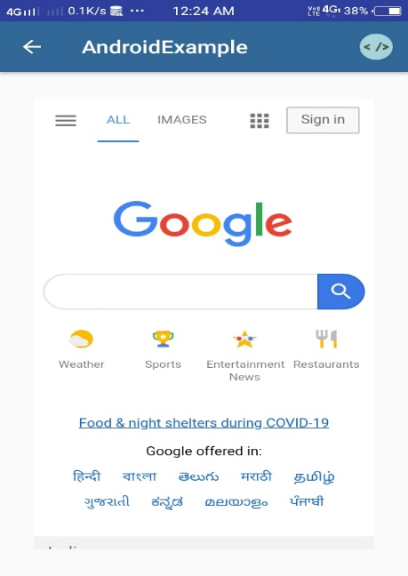

* **Working of the application**

1. We host a simple PHP server on the main station PC, and we keep the server running 24/7.

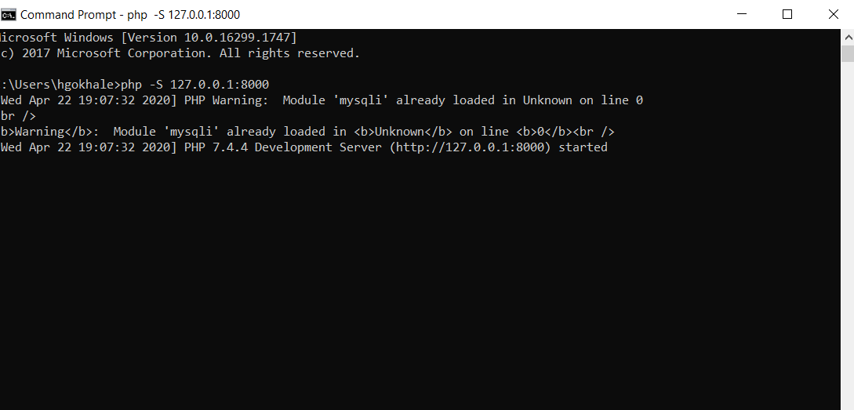

1. We can connect to this server using the IP address of the main station PC.
2. This IP is assigned by the ISP based on daily or hourly basis, so we can assign a static IP to the PC using the router. This will help to generate a single link only once and we can put it in the app.
3. Once the app is in the same network, we can easily access the PC using link http://<ip_address_of_server_pc>:<port_no> which we will embed in the app during development. For more information, [read here](https://stackoverflow.com/questions/4779963/how-can-i-access-my-localhost-from-my-android-device) .

* **User-Interface of the Website**

